Document information
Info | Content
Keywords | QN9020, ARM, ARM Cortex-M0, 32bit, BLE, Proprietary, Microcontroller
Abstract | QN9020 Proprietary user manual

Revision history
Rev | Date | Description
1.0 | <20151106> | First edition
<M.m> | <yyyymmdd> | <revision description, including important changes re. previous version; no author name(s); latest information in top row>

Introduction
The QN9020 chip is an high performance 2.4GHz transceiver, supporting Bluetooth Low Energy(BLE) and proprietary mode. When working on proprietary mode, the data frame format, speed and channel can be configure and transferred directly without BLE stack.
This document is used to introduce the proprietary mode including, data transfer process, and programing guide.
Additionally, sleep and timer feature will be show for low power application.

Proprietary programming guide

Data transfer process
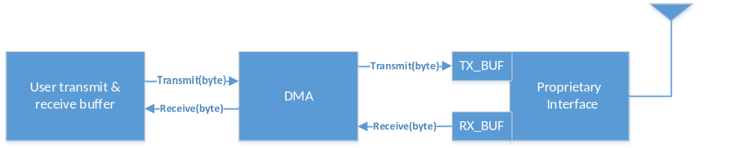

Transceiver frame format
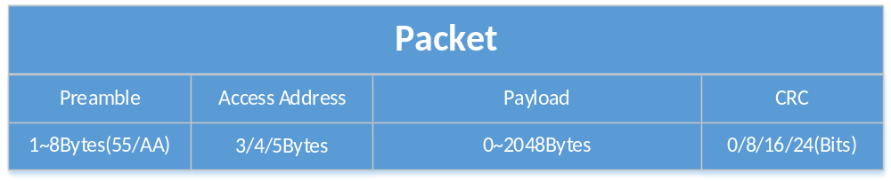

Preamble
The preamble value and length is user configured and preamble value is based on Access Address field.
If the first bit in the Access Address is 1, Preamble value is 0xAA;
If the first bit in the Access Address is 0, Preamble value is 0x55;
Note: “The first bit”: Assume Access Address first byte = 0x11 = 00010001b
If MSB configured in the Proprietary Interface register, the first bit is 0
If LSB configured in the Proprietary Interface register, the first bit is 1

Access Address
Access Address can be configure to 3, 4 or 5bytes. If 5bytes configure, the 5th byte is in prop_aa_addr_in[7:0].

Payload
Payload length support up to 2048bytes, and configured in rx_pdu_len_in[13:0], unit is bit. So if payload length is 1bytes, the value 1<<3 = 8bit should be configured.

CRC
CRC calculate including Access Address and Payload.
8bits: X8 + X2 + X + 1
16bits: X16 + X12 + X5 + 1
24bits: X24 + X10 + X9 + X6 + X4 + X3 + X + 1;

Programming guide
- Configuration parameters
1) Configure the Preamble, Access address, Payload and CRC length.
2) Transmit or receive mode
3) CRC calculate and error check
4) Data rate
5) RF channel
6) Access address takes effect when receive mode configured.

- Transmit
1) The transmit buffer should contain Preamble, Access address and Payload. CRC will be calculate and send by hardware automatically.
2) CRC calculated including Access address and Payload.
3) Before starting a new transmission, TX_BUSY bit in PROP_STATE register should be check to confirm last sending was completed.
4) DMA complete interrupt means, the data in user transmit buffer has been transferred to TX_BUF complete. But the TX_BUF data may not be empty, for the transceiver from Proprietary interface to Data Path does not complete.

- Receive
1) The receive buffer contain Payload and CRC.
2) Hardware constantly searches for a valid packet, if the access address matching, the received data can be got from PROP_RX_BUF register. And if DMA enabled, it will transfer data from PROP_RX_BUF to user receive buffer.
3) The crc_error bit in Data Path register offset 0x3C can be used to check the received packet.
Note: Transmit & receive buffer are user defined.

- DMA
To keep the bit stream continues and relieve the CPU load, DMA should be used. So DMA done flag used during the data transfer, TX_INT and RX_INT bit in the proprietary interface register do not be used.

Sleep and timer

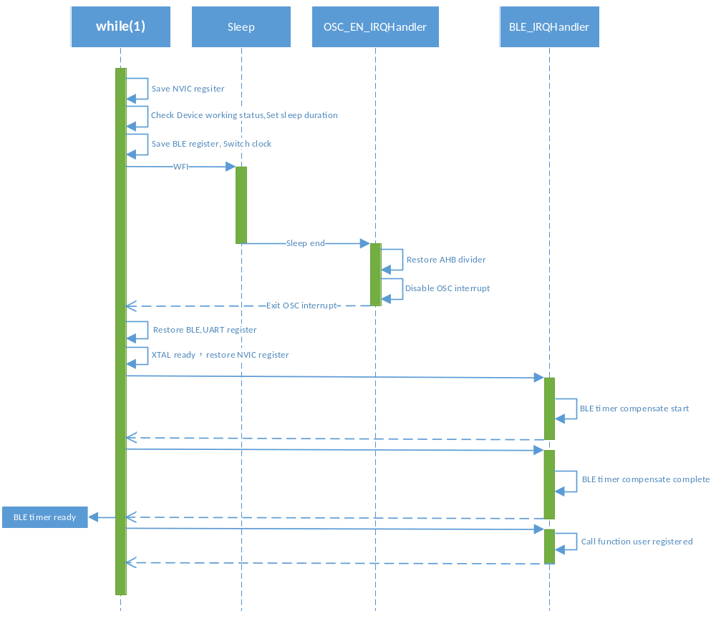Timer wake up
Proprietary function check for sleep automatic, depending on the BLE timer. If the BLE timer interrupt is set by user but not arrived yet, proprietary calculates the sleep duration and then enter sleep mode.
User can register a callback function, when the timer coming(Base count interrupt), the function will be called.

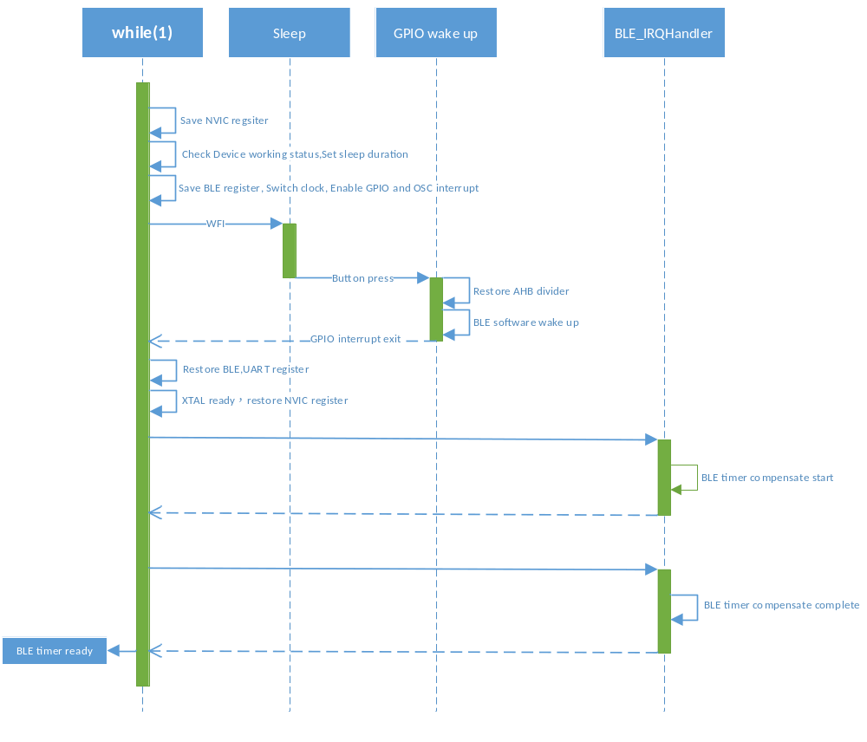GPIO wake up

GPIO wake up the QN9020 while in sleep mode. After waken up, BLE timer compensate will be start, then BLE slot interrupt indicates compensate complete.
Only after compensate operation complete, BLE timer is ready. Then user can get and set timer interrupt.

Power

Timer wakeup and transmit power
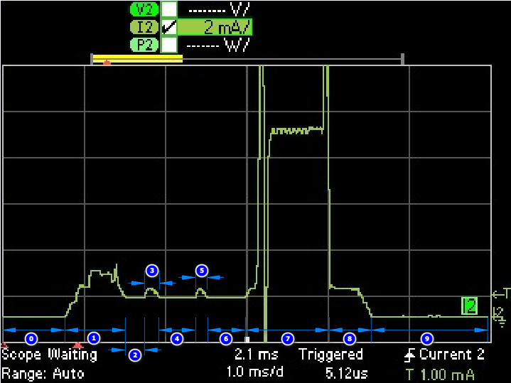
Item | States | Duration(us) | Current(mA)
0 | Sleep | uncertain | 0.0027
1 | OSC wakeup | 730 | 1.9
2 | Idle | 217 | 0.8
3 | MCU compensate start | 220 | 1.3
4 | Idle | uncertain | 0.8
5 | MCU compensate end | 173 | 1.3
6 | Idle | uncertain | 0.8
7 | Transmit data | 1100 | 8.3
8 | MCU check for sleep | 457 | 1.3
9 | Sleep | uncertain | 0.0027

Uncertain note:
Item 0, 9: Sleep duration depend on timer set.
Item 4, 6: Depend on sleep entrance and duration time.

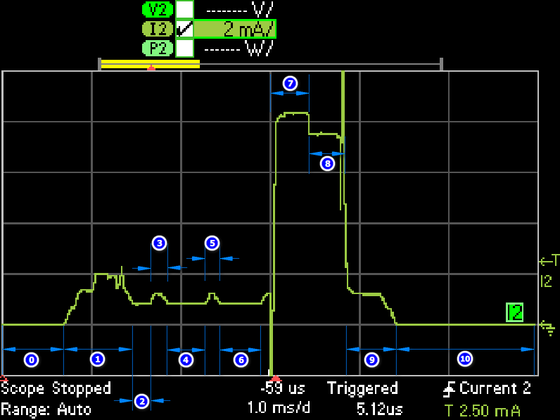
Receive power

Item | states | Duration(us) | Current(mA)
0 | Sleep | uncertain | 0.0027
1 | OSC wakeup | 730 | 1.9
2 | Idle | 217 | 0.8
3 | MCU compensate start | 220 | 1.3
4 | Idle | uncertain | 0.8
5 | MCU compensate end | 173 | 1.3
6 | Idle | uncertain | 0.8
7 | Synchronous | uncertain | 8.34
8 | Receiving data | 432 | 7.5
9 | Check for sleep | 522 | 1.3
10 | Sleep | uncertain | 0.0027

Uncertain note:
Item 0, 9: Sleep duration depend on program set.
Item 4, 6: Depend on sleep entrance and duration time.
Item 7: Depend on sending part.

Programming API

Function Documentation

__STATIC_INLINE void prop_ctrl_reset (void )

Proprietary control register reset.

static void prop_freq_set (enum RF_MODE rf_mode, uint8_t rf_idx)[static]

Proprietary frequency set.

Parameters:
in | rf_mode | RF in tx or rx mode
in | rf_idx | Proprietary RF frquency table index

Note:
rf_freq_tab[] is LO_FRAC part value RF frequency = 48 * (32 + LO_INT + LO_FRAC / 2 ^ 20) => 48 * (32 + LO_INT + rf_freq_tab[] / 2 ^ 20) eg. rf_idx = 24 ===> rf_freq_tab[rf_idx] = 0x80000 48 * (32 + 0x12 + 0x80000 / 2 ^ 20) = 2424Mhz
rf_idx = 76 ===> rf_freq_tab[rf_idx] = 0x95555 48 * (32 + 0x13 + 0x95555 / 2 ^ 20) = 2475.999985MHz
If RF_TX frequecy = 2424MHz => RF_Rx_IMR0 = 2424 - 1 = 2423MHz => RF_Rx_IMR1 = 2424 + 1 = 2425MHz

void prop_init (enum PROP_PREAMBLE_NUM_TYPE preamble_num, enum PROP_CRC_NUM_TYPE crc_num, enum PROP_DATA_RATE_TYPE data_rate)

Proprietary initialization.

Parameters:
in | preamble_num | Preamble length
in | crc_num | CRC length
in | data_rate | Data rate

void prop_mode_tx (uint8_t rf_idx, uint8_t * aa_buf, enum PROP_AA_NUM aa_num, uint8_t * data_buf, uint16_t data_len)

Proprietary mode transmit.

Parameters:
in | rf_idx | RF frequency index Get this parameter from rf_freq_tab[] accroding to the frequency chosen
in | aa_buf | Access address buffer, destination device address
in | aa_num | Access address length
in | data_buf | Transmit data buffer
in | data_len | Transmit data length

void prop_mode_rx (uint8_t rf_idx, uint8_t * aa_buf, enum PROP_AA_NUM aa_num, uint8_t * data_buf, uint16_t data_len)

Proprietary mode receive.

Parameters:
in | rf_idx | RF frequency index Get this parameter from rf_freq_tab[] accroding to the frequency chosen
in | aa_buf | Access address buffer, own device address
in | aa_num | Access address length
in | data_buf | Receive data buffer
in | data_len | Receive data length

uint8_t prop_crc_check (void )

receive buffer crc check

Returns:
0: receive data right 1: receive data crc error

void prop_mode_stop (void )

Proprietary mode break This function should be called after transmission and receive complete to save power.

void prop_timer_init (void(*)(void) callback)

Register timer callback function.

uint32_t prop_timer_get (void )

Get current time value from HW.

Returns:
The current time in units of 625us

void prop_timer_set (uint32_t time)

Set the HW timer.

Parameters:
in | timer | Timer value in units of 10ms

void prop_timer_clear (void )

Clear the HW timer.

- Legal information

  - Definitions
Draft — The document is a draft version only. The content is still under internal review and subject to formal approval, which may result in modifications or additions. NXP Semiconductors does not give any representations or warranties as to the accuracy or completeness of information included herein and shall have no liability for the consequences of use of such information.
  - Disclaimers
Limited warranty and liability — Information in this document is believed to be accurate and reliable. However, NXP Semiconductors does not give any representations or warranties, expressed or implied, as to the accuracy or completeness of such information and shall have no liability for the consequences of use of such information. NXP Semiconductors takes no responsibility for the content in this document if provided by an information source outside of NXP Semiconductors.
In no event shall NXP Semiconductors be liable for any indirect, incidental, punitive, special or consequential damages (including - without limitation - lost profits, lost savings, business interruption, costs related to the removal or replacement of any products or rework charges) whether or not such damages are based on tort (including negligence), warranty, breach of contract or any other legal theory.
Notwithstanding any damages that customer might incur for any reason whatsoever, NXP Semiconductors’ aggregate and cumulative liability towards customer for the products described herein shall be limited in accordance with the Terms and conditions of commercial sale of NXP Semiconductors.
Right to make changes — NXP Semiconductors reserves the right to make changes to information published in this document, including without limitation specifications and product descriptions, at any time and without notice. This document supersedes and replaces all information supplied prior to the publication hereof.
Suitability for use — NXP Semiconductors products are not designed, authorized or warranted to be suitable for use in life support, life-critical or safety-critical systems or equipment, nor in applications where failure or malfunction of an NXP Semiconductors product can reasonably be expected to result in personal injury, death or severe property or environmental damage. NXP Semiconductors and its suppliers accept no liability for inclusion and/or use of NXP Semiconductors products in such equipment or applications and therefore such inclusion and/or use is at the customer’s own risk.
Applications — Applications that are described herein for any of these products are for illustrative purposes only. NXP Semiconductors makes no representation or warranty that such applications will be suitable for the specified use without further testing or modification.
Customers are responsible for the design and operation of their applications and products using NXP Semiconductors products, and NXP Semiconductors accepts no liability for any assistance with applications or customer product design. It is customer’s sole responsibility to determine whether the NXP Semiconductors product is suitable and fit for the customer’s applications and products planned, as well as for the planned application and use of customer’s third party customer(s). Customers should provide appropriate design and operating safeguards to minimize the risks associated with their applications and products.
NXP Semiconductors does not accept any liability related to any default, damage, costs or problem which is based on any weakness or default in the customer’s applications or products, or the application or use by customer’s third party customer(s). Customer is responsible for doing all necessary testing for the customer’s applications and products using NXP Semiconductors products in order to avoid a default of the applications and the products or of the application or use by customer’s third party customer(s). NXP does not accept any liability in this respect.
Export control — This document as well as the item(s) described herein may be subject to export control regulations. Export might require a prior authorization from competent authorities.
Translations — A non-English (translated) version of a document is for reference only. The English version shall prevail in case of any discrepancy between the translated and English versions.
Optional text for evaluation products; remove if not required.
Evaluation products — This product is provided on an “as is” and “with all faults” basis for evaluation purposes only. NXP Semiconductors, its affiliates and their suppliers expressly disclaim all warranties, whether express, implied or statutory, including but not limited to the implied warranties of non-infringement, merchantability and fitness for a particular purpose. The entire risk as to the quality, or arising out of the use or performance, of this product remains with customer.
In no event shall NXP Semiconductors, its affiliates or their suppliers be liable to customer for any special, indirect, consequential, punitive or incidental damages (including without limitation damages for loss of business, business interruption, loss of use, loss of data or information, and the like) arising out the use of or inability to use the product, whether or not based on tort (including negligence), strict liability, breach of contract, breach of warranty or any other theory, even if advised of the possibility of such damages.
Notwithstanding any damages that customer might incur for any reason whatsoever (including without limitation, all damages referenced above and all direct or general damages), the entire liability of NXP Semiconductors, its affiliates and their suppliers and customer’s exclusive remedy for all of the foregoing shall be limited to actual damages incurred by customer based on reasonable reliance up to the greater of the amount actually paid by customer for the product or five dollars (US$5.00). The foregoing limitations, exclusions and disclaimers shall apply to the maximum extent permitted by applicable law, even if any remedy fails of its essential purpose.
  - Licenses
Purchase of NXP <xxx> components
<License statement text>
  - Patents
Notice is herewith given that the subject device uses one or more of the following patents and that each of these patents may have corresponding patents in other jurisdictions.
<Patent ID> — owned by <Company name>
  - Trademarks
Notice: All referenced brands, product names, service names and trademarks are property of their respective owners.
<Name> — is a trademark of NXP Semiconductors N.V.

Index

D
Dummy index entry 3

List of figures

No table of figures entries found.

List of tables

No table of figures entries found.

Contents

1. Introduction 3
2. Proprietary programming guide 3
2.1 Data transfer process 3
2.2 Transceiver frame format 3
2.2.1 Preamble 3
2.2.2 Access Address 4
2.2.3 Payload 4
2.2.4 CRC 4
2.3 Programming guide 5
3. Sleep and timer 6
3.1 Timer wake up 6
3.2 GPIO wake up 7
4. Power 8
4.1 Timer wakeup and transmit power 8
4.2 Receive power 9
5. Programming API 10
5.1 Function Documentation 10
5.1.1 __STATIC_INLINE void prop_ctrl_reset (void ) 10
5.1.2 static void prop_freq_set (enum RF_MODE rf_mode, uint8_t rf_idx)[static] 10
5.1.3 void prop_init (enum PROP_PREAMBLE_NUM_TYPE preamble_num, enum PROP_CRC_NUM_TYPE crc_num, enum PROP_DATA_RATE_TYPE data_rate) 10
5.1.4 void prop_mode_tx (uint8_t rf_idx, uint8_t * aa_buf, enum PROP_AA_NUM aa_num, uint8_t * data_buf, uint16_t data_len) 10
5.1.5 void prop_mode_rx (uint8_t rf_idx, uint8_t * aa_buf, enum PROP_AA_NUM aa_num, uint8_t * data_buf, uint16_t data_len) 11
5.1.6 uint8_t prop_crc_check (void ) 11
5.1.7 void prop_mode_stop (void ) 11
5.1.8 void prop_timer_init (void(*)(void) callback) 11
5.1.9 uint32_t prop_timer_get (void ) 11
5.1.10 void prop_timer_set (uint32_t time) 11
5.1.11 void prop_timer_clear (void ) 11
6. Legal information 12
6.1 Definitions 12
6.2 Disclaimers 12
6.3 Licenses 12
6.4 Patents 12
6.5 Trademarks 12
7. Index 13
8. List of figures 14
9. List of tables 15
10. Contents 16

